**CREATIVE EDUCATIONAL SERVICES**

**BEGINNING OF TERM I EXAMINATIONS 2024**

**LITERACY 1A**

**PRIMARY ONE**

**Name:……………………………………………………Class: ……….………..……**

**School: …………………………………………………………………………………**

1. 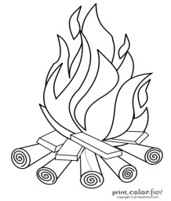**Name these dangerous objects.**

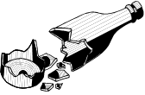

__________ __________

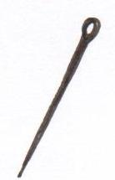

__________ ___________

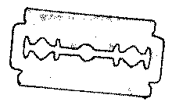

__________

1. **Ring the correct word.**

dress rdess desrs

ite tei tie

ksirt skirt stirk

blte blet belt

coat caot toac

1. **Fill in the missing letters.**

sp ____nge b___sin co___b

w ___ter t__ ___thbrush s___ap

1. **Match pictures to words.**

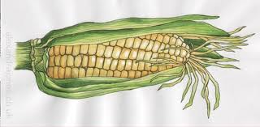

fish

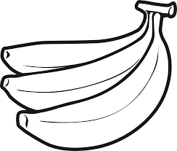

eggs

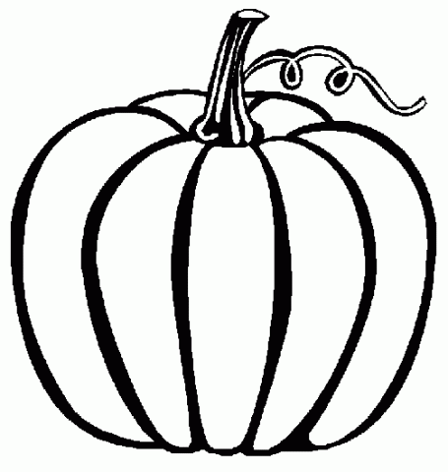

pumpkin

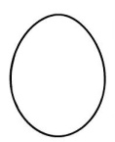

bananas

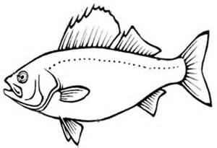

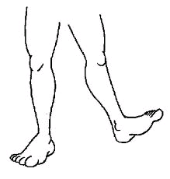 maize

1. **Write correctly.**

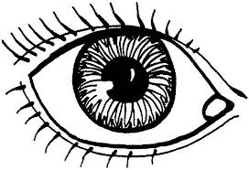

yee __________ gel _______

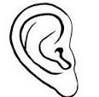

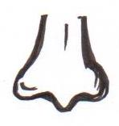

onse _________ aer _______

1. **Match body parts to their senses.**

eyes feeling

nose tasting

tongue hearing

skin smelling

ears seeing

1. **Name these things found in the first aid box.**

[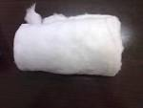](http://www.google.com/imgres?imgurl=http://image.made-in-china.com/2f0j00jBnQHoNFpycV/Absorbent-Cotton-Wool.jpg&imgrefurl=http://medicalequipment.en.made-in-china.com/product/SMrmBaiorCVj/China-Absorbent-Cotton-Wool.html&usg=__H4jW88wOlZOg4MKpOJQjfYI4GoM=&h=768&w=1024&sz=70&hl=en&start=6&zoom=1&tbnid=UfpwzcRexYsh4M:&tbnh=113&tbnw=150&ei=usd_UYSTCqrc4QT6hYH4Bg&prev=/search?q=cotton+wool&hl=en&gbv=2&tbm=isch&itbs=1&sa=X&ved=0CDYQrQMwBQ)

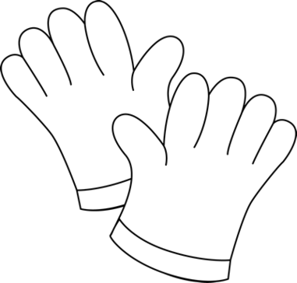

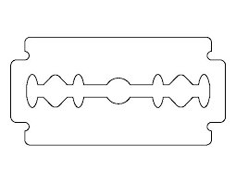 _________ _______ ______



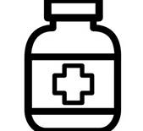

[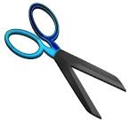](http://www.google.com/imgres?imgurl=https://upload.wikimedia.org/wikipedia/commons/9/92/Scissors.png&imgrefurl=https://commons.wikimedia.org/wiki/File:Scissors.png&usg=__Y4NS-xuI_p8FyqPB8fH2xDnbwDU=&h=838&w=886&sz=196&hl=en&start=12&zoom=1&tbnid=3acgBONekaeOWM:&tbnh=138&tbnw=146&ei=zcZ_UbmWMM6u7AafsICYDw&prev=/search?q=scissors&hl=en&gbv=2&tbm=isch&itbs=1&sa=X&ved=0CEIQrQMwCw)

_________ _______ ______

razorblade, scissor, medicine, gloves, spirit, cotton

1. **Read and draw.**

tooth paste basin

soap water towel

1. **Make sentences.**

________________________________

________________________________

________________________________

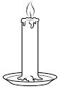

________________________________

1. **Oral**
2. Why do we brush our teeth?
3. What is an accident?
4. List down 3 common accidents.
5. What do we use for smelling?
6. Give three things we use when giving first aid.
7. Why do we wash our hands before eating food?

**End**